**See general Esri K12 resources here**<https://community.esri.com/community/education/blog/2020/03/16/is-your-school-or-district-rapidly-planning-to-move-courses-online>

**POD Geospatial Inquiry Self Directed Projects**

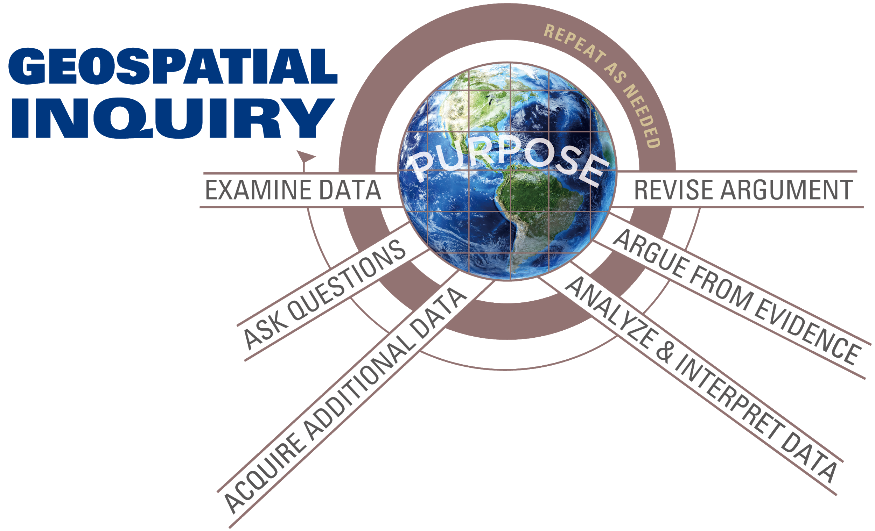**Geospatial Inquiry cycle - start with either one:**

* **Examine Data**

Explore some [interesting maps and patterns](https://storymaps-classic.arcgis.com/en/gallery/#s=0) to inspire a question or a PURPOSE. These story maps can be filtered by subject.

* **Ask Questions**

Start with a question or community problem you already have in mind. Explore a natural [phenomenon](https://www.ngssphenomena.com/) that can be explained.

* Need ideas? [Guiding questions submitted to POD](https://docs.google.com/document/d/16xKfllcdEHdENFnQee0a8mA0OMtDMkFha4edwj-HA4Y/edit)
* What information do you need? What data do you need to acquire? How will you analyze and interpret the data?

NOTE TO TEACHERS: Finding data at the appropriate scale can be challenging. It is recommended you guide students to a question for which data exists or provide some data layers to explore. Try mining [GeoInquiries](https://www.esri.com/en-us/industries/education/schools/geoinquiries-collections) for interesting layers.

**Acquire data**

ArcGIS Online is relatively straightforward for simple mapping needs but may not be as you dig deeper into the interface. It is a “crowd-sourced” collection of data so you will always want to check the Details page for creator and metadata

* The [Living Atlas](https://livingatlas.arcgis.com/en/browse/#d=2), which is free with an Organizational Account, is authoritative data and can be filtered by subject. See also <https://learn.arcgis.com/en/projects/get-started-with-arcgis-living-atlas-of-the-world/>
* Use our [Buckets of Data](https://docs.google.com/spreadsheets/d/199sS0hj9-Mmn5PvWTGv1WrMmj9O0rpUc5PVYlNruizc/edit#gid=0) which have been vetted.
* Check out your local city, county, state GIS data sites. For example, Arizona Geographic Information Council has<http://azgeo-azland.opendata.arcgis.com/>
* [ArcGIS Hub](https://hub.arcgis.com/pages/gallery#hubsbysector) has more open data browsable by category.

Create your own data

* Simple spreadsheet (.txt or .csv) and add to your AGOL map
* Add points, lines, or polygons in Map Notes. Save it as a layer
* Collect data from others in [Survey 123](https://survey123.arcgis.com/) or [Quick Capture](https://www.esri.com/en-us/arcgis/products/arcgis-quickcapture/overview) or use an [App](https://doc.arcgis.com/en/arcgis-online/create-maps/choose-configurable-app.htm)
  + [Mapping for Impact - using Survey 123](https://docs.google.com/document/d/1oqsWP5AeeGSCGCDEA--n23Mc64zu_x8OTGgQwUYYYj0/edit)

**Analyze and Interpret Data**

Use the Styles menu to display the data to highlight patterns and relationships. Smart mapping can help (by size, by color, by color and size, heat maps). For more, see<https://www.arcgis.com/apps/Cascade/index.html?appid=e71df22089774da8afbe305ad7fd6111>.

Consider the Geospatial Analysis Framework (Mitchell, 1999)

1. Examining where things are (why might things be there instead of somewhere else?)

2. Examining most and least (such as populations)

3. Finding areas of concentration/density (clumps of data in an area)<https://doc.arcgis.com/en/arcgis-online/analyze/calculate-density.htm>

4. Finding what’s inside (consider natural borders and municipal ones such as cities, states, counties and census tracts, or inside a boundary you create like a 1 mile buffer zone or walking or biking distance area)<https://doc.arcgis.com/en/arcgis-online/analyze/create-buffers.htm>

5. Finding what’s nearby (related to where things are - why might these things be close to one another?)<https://doc.arcgis.com/en/arcgis-online/analyze/find-nearest.htm>

6. Examining change over time (has it always looked like this or has it changed a lot? What might have led to these changes?)

Feeling adventurous? Explore these analyses and examples:<https://doc.arcgis.com/en/arcgis-online/analyze/perform-analysis.htm>

**Argue from Evidence**

Make a claim about the patterns and relationships that you see. What data do you have that can support your claim?

Present your argument using any number of ways:<https://doc.arcgis.com/en/arcgis-online/create-maps/choose-configurable-app.htm> - invite feedback and make revisions as necessary.