**Geospatial Inquiry Template**

**Teacher**

**Grade level(s)**

**Subject(s)**

**Existing lesson/unit to be *enhanced* by Geospatial Inquiry**

**Anticipated timeframe**

**Anticipated implementation (month, year)**

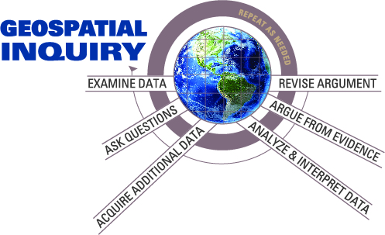

**Begin with the End in Mind**

What essential understanding will students gain from completing this Geospatial Inquiry-enhanced lesson/unit? A concept is an idea that can be applied in multiple contexts to explain and/or predict outcomes. Conceptual understanding is ability to apply a big idea/concept in multiple contexts to explain and/or predict outcomes.

*Have you written a statement that allows students to apply a broad idea in multiple contexts to explain and/or predict outcomes?*

Identify 2-3 key skills and/or cross-disciplinary practices students will learn or use during this Geospatial Inquiry-enhanced lesson/unit (e.g. collaboration, communication)

**Ask Questions**

Craft a guiding question which provides a purpose for engaging in the Geospatial Inquiry-enhanced lesson/unit. The statement should encompass all content and outcomes and should require to answer a question, solve a problem or explain a phenomenon.

*Have you posed an authentic problem or significant question that engages students and requires core subject knowledge to solve or answer?*

**Geospatial Analysis Framework**

Which types of geospatial analyses will students conduct to find relationships and patterns in order to develop conceptual understanding?

Check all that apply:

* Finding where things are (in relation to other things)
* Finding what’s nearby
* Examining what’s inside
* Comparing most and least
* Finding areas of concentration (density)
* Examining change over time

For each item checked above, what will students analyze, compare, and/or interpret (not specific datasets, but big ideas)?

**Evidence of Student Learning**

Define the student products for the Geospatial Inquiry-enhanced lesson/unit.

Which of these (or other products) will you assess? Which products require feedback to enable students to refine their thinking?

Early on:

In the middle:

Final product:

*Do students have multiple opportunities to ask questions, analyze and interpret geospatial data, argue from evidence, present their arguments, and revise their thinking?*

**Quality of Evidence**

State the criteria for exemplary performance for each product:

Product:

Criteria:

Product:

Criteria:

Product:

Criteria:

*Do the products and criteria align with identified outcomes?* *Do the products and tasks give all students the opportunity to demonstrate what they have learned not only through visual representations, but also through writing and speaking?*

**Examine Geospatial Data**

What maps or data could students explore to spark questions and engage them in the investigation? Is a video or news story appropriate to introduce these maps or data? Is there a career connection that could be embedded?

**Map the Geospatial Inquiry**

You have defined the problem or question and the student products for a Geospatial Inquiry-enhanced lesson/unit above. What knowledge and skills do students need in order to make the decision, explain the phenomenon, or answer the guiding question? What additional learning activities (hands on investigations, readings, etc.) must be completed to accompany the Geospatial Inquiry? Please describe the major activities for the entire lesson/unit, before, during, and after the Geospatial Inquiry, as appropriate.

|  |  |  |
| --- | --- | --- |
| **Activity Description** | **Learning Goal** | **How it helps students address the guiding question** |
|  |  |  |
|  |  |  |
|  |  |  |
|  |  |  |

Identify activities which require scaffolds for writing or participation.

|  |  |
| --- | --- |
| **Activity** | **Type of Scaffold** |
|  |  |
|  |  |
|  |  |
|  |  |

*Have you identified opportunities to promote productive talk?*

What challenges or problems might arise in this Geospatial Inquiry-enhanced lesson/unit? How will you overcome these challenges?