Creating a simple Editable Feature service:
Using an ArcGIS Online for Organizations subscription, anyone with a “Publisher” account (not a first-level “User” account) can create and publish an Editable Feature Service (EFS). Editable Feature Services can be simple or complex, allowing for the use of “controlled” data inputs or allowing for free text assigned to each field. An EFS can allow attached photos to be uploaded and shared and security can be set to allow group, organization, or everyone to view or contribute data. Data contributors can be allowed to add to, edit, delete, or any combination therein.
Establishing a Simple EFS based on a CSV
- Create a CSV file using Microsoft Excel or Google Drive Spreadsheet.

- The fieldnames of the spreadsheet are in the first row.
For example:
Latitude | Longitude | Tree_Type | Diameter | Est_Tree_Height | Bark_Condition

- Do not bother putting data in the spreadsheet. You will do this from the map, later. Save the spreadsheet column names by one of the following methods:
  - Excel: “File” -> “Save As” -> [Save as Type] -> “CSV (MS DOS)”
  - Google Drive: “File” -> “Download As” -> “Comma Separated Value”

- Optional way to check your work: Find the CSV file you just saved and open it in Notepad (Windows) or TextEdit (Macintosh) by right clicking the file name and selecting “Open With”. Here is what the file will look like.

Latitude,Longitude,Tree_Type,Diameter,Est_Tree_Height,Bark_Condition

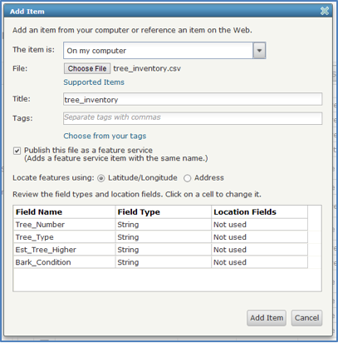
- Open a browser and login to your school or club’s ArcGIS Online for Organizations subscription. Remember, your account must have at least “Publisher” permissions.

- Click “My Content” in the top navigation.

- Press, “Add Item”, “From My Computer” and “Choose File”.

- Enter a title, tags, and locate features using Latitude/Longitude.

- Be sure to check “Publish this file as a hosted layer

- Press “Add Item”

- The details of your new feature service will be displayed.

- In the Overview tab under the “Layers” section of the page, click on “Enable Attachments”. This allows photos to be uploaded when contributing data, especially using mobile applications like “ArcGIS” or “Collector”.
Note: You do not need to press the Publish button. This function creates a tiled map service of your data. Consider using this option only if your data set becomes very large.

- Turn the feature service into an editable feature service (EFS):
  - On the Overview tab, click on the “Edit” pencil.
  - Fill in the Title, Description, and summary.
  - On the Settings tab under “Feature Layer (Hosted) Settings choose the “Enable editing” that allows editors to: Add, update, and delete features.
  - You may choose “Enable Sync” if you wish to do disconnected editing while in the field.
  - Click on “Save” button.

- On your new feature service’s Overview tab, the page has a place for a small thumbnail view of a map in the upper left corner), click “Edit Thumbnail” and navigate to the image and Save. Click on “Open in Map Viewer” and select “Add layer to new map”.

- If everything worked, you will notice a new “Edit” button on the top navigation bar of the map. Press “Edit”. Click on a desired symbol then click the target location on your map.

- Fill out the fields in the popup window.

- Press “Save” and “Share” your map to the group, organization, or everyone.

- Optional: Review the shared map application from this example at http://bit.ly/13jkCUa
